
15735 S. MAHAFFIE
OLATHE, KANSAS 66062
_______________(913) 764-6229 PHONE _ (913) 764-8198 FAX______________
WATERPROOFING----DRAINTILE-----SUMP PUMPS-----ATTIC FANS-----EROSION CONTROL

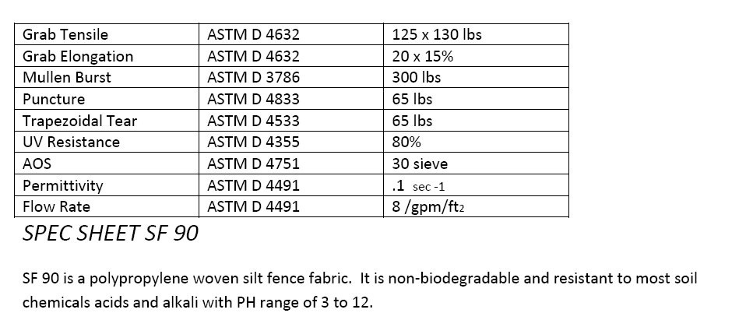

The above 90 gram fabric is assembled with 2” x 4” Galvanized Welded wire. The wire is 14 gauge and 24” wide on the silt fence roll.

