
15735 S. MAHAFFIE
OLATHE, KANSAS 66062
_______________(913) 764-6229 PHONE _ (913) 764-8198 FAX______________
WATERPROOFING----DRAINTILE-----SUMP PUMPS-----ATTIC FANS-----EROSION CONTROL

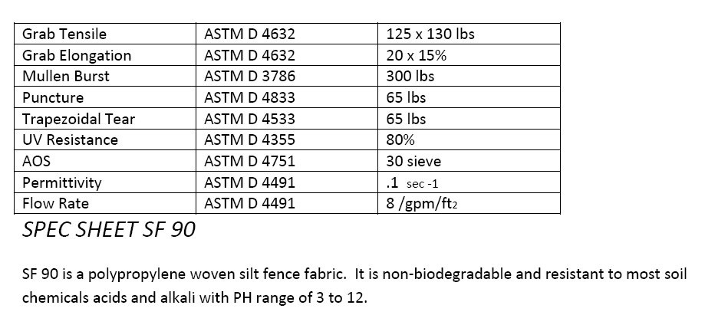

The above 90 gram fabric is assembled with 13 stakes per roll. Stake spacing is 8’ on center. The heavy duty wood stakes are made of mostly oak or other hardwoods. The stakes are 2” x 2” nominal x 48” tall. The fabric is 36” wide/tall which includes a 6” flap at the bottom that is trenched in the ground.

