
PHONE: (913) 764-6229 FAX: (913) 764-8198

WATERPROOFING---DRAIN TILE---SUMP PUMPS----EROSION CONTROL--SEEDING---FRENCH DRAINS---BRUSH HOGGING

PRODUCT USE: STORM SEWER INLET PROTECTION

PRODUCT NAME: HEAVYWEIGHT MULCH BAG

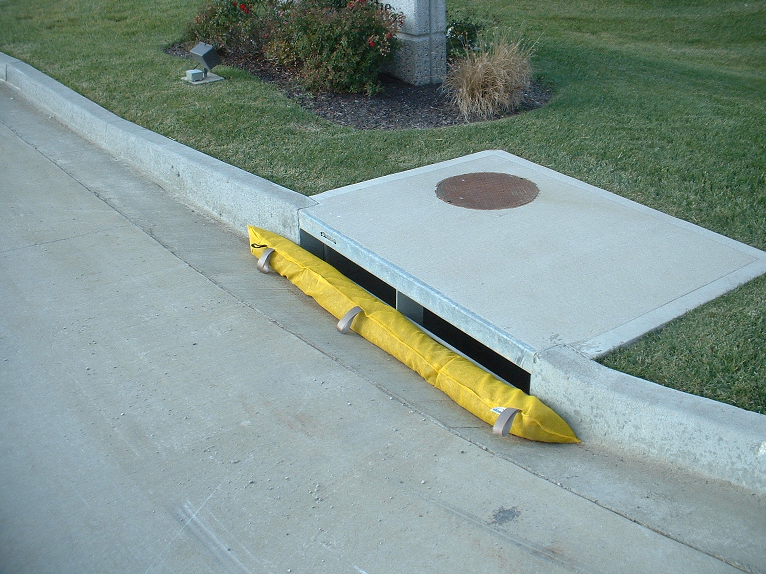

PRODUCT DESCRIPTION: The bag is made from a high UV, woven monofilament polypropylene filter fabric. (100% USA fabric & sewing thread). They come with sewn on lift loops to help in moving the bags. 1 end of the bag is sewn shut, and the other end (for filling) has a “self closing” envelope enclosure. It is designed to conform to the shape of the inlet to help reduce the passage of sediment. It is a 1-piece design to help eliminate those gaps that allow sediment through.

The bag is filled with wood safety chips. These wood chips provide drainage and provides weight to hold the bag in place. The chips are designed to last up to 1 year. Additional wood chips may be added to the bag as routine maintenance if needed. (Gravel may be substituted as an alternate drainage material)

Materials: 6.2 oz, 350/250 lb tensile strength, 1200 hr UV stabilized, 100% polypropylene, # 40 US sieve, 100 gallons per square foot.

Dimensions: Approximately 7” diameter x 8’ long.

Color: Yellow or Green
G:Sales/ProductInfo/ErosionControl

